1. Before You Start 1
2. Getting Started 2
3. Register for a new account (if required) 2
4. Complete the Pre-check Form 3
5. Honduras Affidavit (Epidemiological Surveillance Sheet and Affidavit of Health) 5
6. Completing the Health Form 6
7. How to print, email, modify or delete your Pre-Check Form 11

Before You Start
  - The Precheck form can be found here https://prechequeo.inm.gob.hn/Login. The link to the Health Form will pop up once the precheck form is completed. The link if needed is https://ee.humanitarianresponse.info/x/3LC6FbGX
  - When traveling to Honduras, both the Precheck (Prechequeo) and the Health Forms (Ficha de Vigilancia Epidemiológica de la Salud) must be completed.
    - You will receive an email with a copy of the precheck once submitted. Save a copy to your Photos on your phone for easier access or in event of losing internet access.
    - Before you submit the Health Form, you need to take a photo of the generated Form ID. This one step MUST be done in the Spanish format as it does not display correctly in English. Detailed instructions are included further down in this document.
NOTE: You will not receive any confirmation message or email upon submission.
Sample of the completed precheck form | Sample Form ID from the completed Health Form
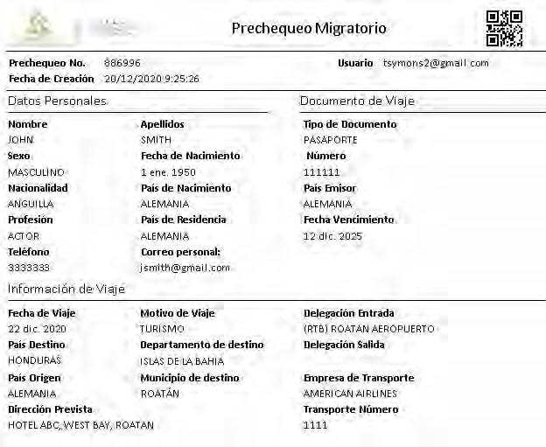 |  | 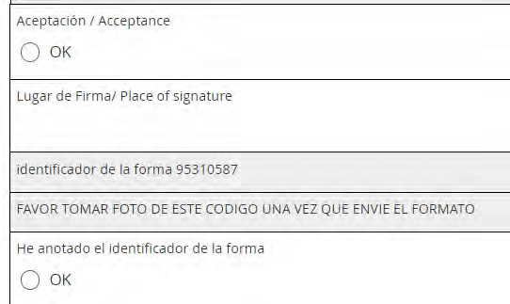
  - You can register immediately, but you cannot complete the forms until it within 2 days of your flight to Honduras.

  - To complete the pre-check and health form, you will need:
    - Your passport (number and expiry date)
    - Details of the flight arriving in Honduras (airline, flight # and date)
    - Address where you will be staying
    - A photo of the following to upload to the health form. File format must be a JPG or PNG. PDF does not work.
      - Copy of your negative COVID test result OR your COVID Vaccination Card provided you have been fully vaccinated for at least 14 days.
      - Copy of your Passport photo page.
  - Technical Issues
    - This site works best with Chrome, Microsoft Edge or Mozilla Firefox. Mac users have reported issues with the site not working and also those with a Hotmail email. Internet Explorer and Safari on Android mobile devices may have issues.
    - If you have an issue with any other device or browser, try using Google Chrome on a PC and failing that, try another device.
    - If the page won’t load, try turning off Wi-Fi and using your cell phone connection (either by doing it on your phone or using your computer or tablet and connection to a hotspot from your phone).
  - When departing Honduras, you’re asked to fill out the Precheck form again. It’s not mandatory, but speeds up the immigration process as they don’t have to gather the information real-time. You do NOT have to print it.

Getting Started
  - Go to the Precheck Home page is https://prechequeo.inm.gob.hn/Login
  - If using a PC, select English on the home page. If you don’t see this option, use Google Chrome and right click anywhere on the screen and select “Translate to English”.
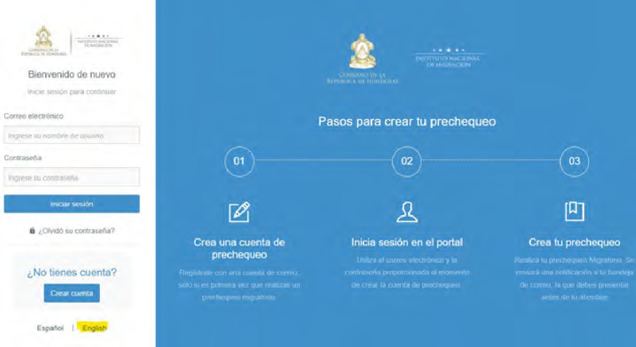
If neither of these options work, use Google Translate https://translate.google.ca/?hl=en&tab=TT
Screenshots included here use the English option which, by default, gives you the translation (except for the dropdowns). Change to English on the initial page if that is your preferred language.

Register for a new account (if required)
- You can register for a new account at any time before you travel. Do this ahead of filling out the form in case of any technical difficulties.
  - If you have registered with the Immigration ALAM system for a Tourist Visa extension or Residency renewal, this is a different account. You need to register here to complete the precheck.

- You must wait to complete the pre-check form within 48 hours of your arrival into Honduras (when you enter the flight date, it only allows you to select today, tomorrow or the next day).
- Forms for each family member can be created within the same account. Do them at the same time because if you do some now and the rest later, it can overwrite the first one(s).
- Tip: For dropdown lists, type the first few letters of the word you want to select and a list of matching words will be displayed.

Complete the Pre-check Form
- To complete the pre-check form, you will need:
  - Your passport (number and expiry date)
  - Flight details (airline, flight # and date)
  - Address of where you will be staying
- On a PC, click on Español and change to English in the top right corner
- Select the ““Create a pre-checkin” to complete the precheck.
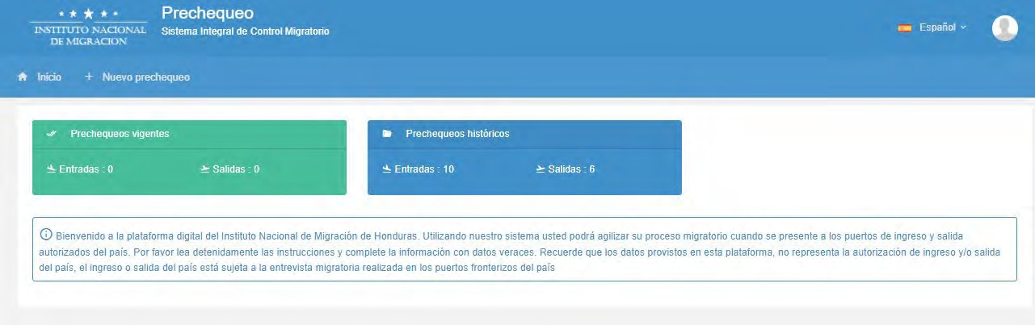

- On a phone, select “Nuevo prechequeo”
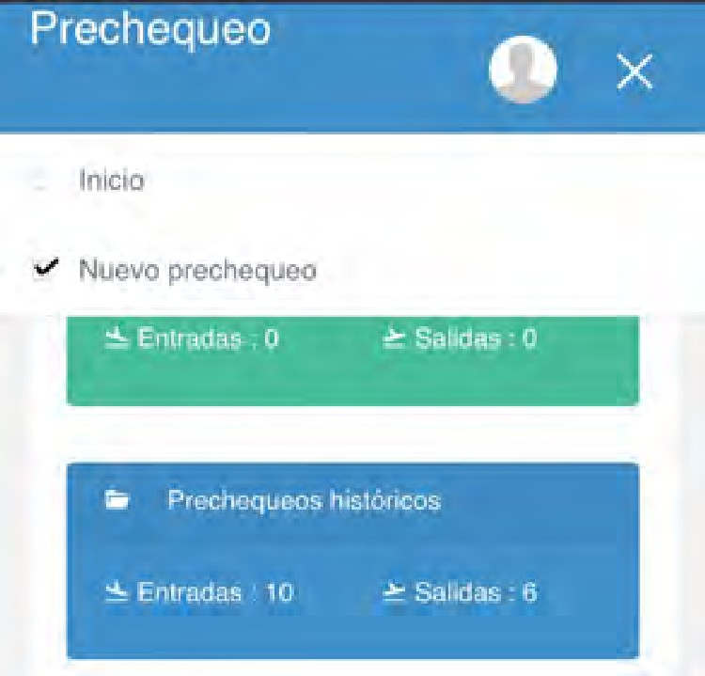

1. Trip Information
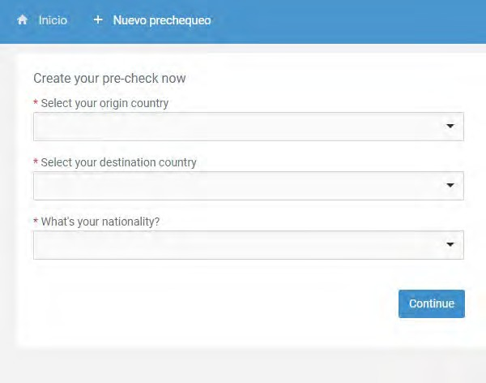  Tip: When selecting a value from a dropdown list, type in the first few letters and a shortlist of matches will appear. | Select your country of origin  This is the country your trip originates in:  - For USA, type “Estad” and Select “Estados Unidos de Norte América”  - For Canada, select “Canada”  - For UK, Select “Reino Unido”  If you are leaving Honduras, select “Honduras” otherwise you will go down the entry questions again.  Select your Destination  If you are coming to Honduras, select “Honduras”  If you are leaving Honduras, select your final destination:  - For USA, type “Estad” and Select “Estados Unidos de Norte América”  - For Canada, select “Canada”  - For UK, Select “Reino Unido”  What’s your nationality?  - For US, Select “United States”  - For Canada, select “Canada”  - For UK, Select “Reino Unido”  Click “Continue”
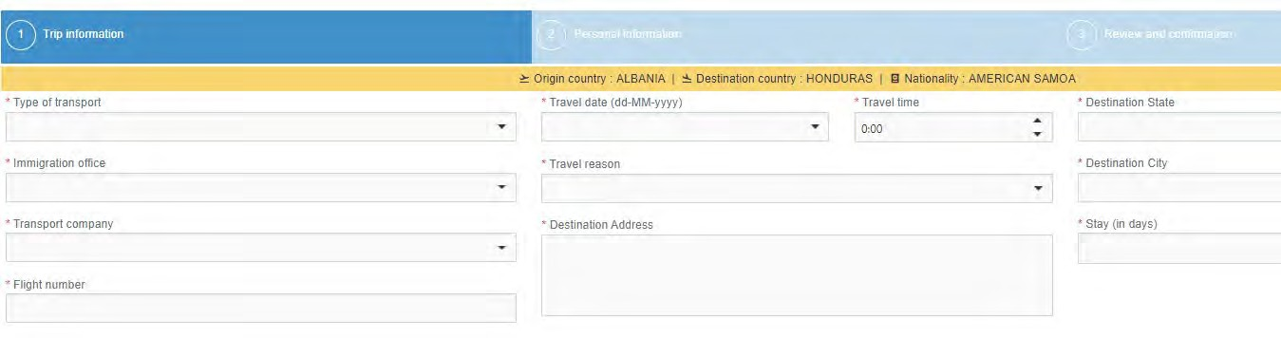
Medio de transporte / Type of transport  Aéreo – air  Delegación/Immigration Office:  Ramon Villeda Morales - San Pedro (SAP)  Empresa de transporte / Transport company  American Airlines or United  Numero de vuelo / Flight Number | Fecha de viaje / Travel date  - Select from calendar  Hora de viaje / Travel (Departure) time Motivo de viaje/Travel reason  Turismo - Tourism  Dirección prevista / Destination Address  Casa de Bernabe  Pena Blanca | Departamento que visita/Destination State This will be your final destination state and city  - Cortes  Municipio que visita – Destination City  San Pedro Sula  Tiempo de estadía (días) / Stay (in days)  8

Personal Information
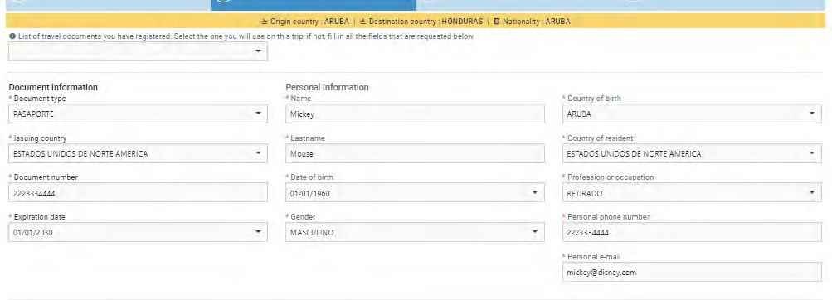

List of travel documents you have registered. Select the one you will use on this trip, fill in all the fields that are requested below.
If you completed any pre-check(s) previously, select your passport information from the dropdown in the top left below the yellow line.
- Document Type – Pasaporte
- Issuing Country – USA = Estados Unidos de Norte América
- Document number – Enter Passport number
- Expiration date - Enter passport expiration date; format is dd-mm-yyyy or pick from the calendar.
- Date of birth –Enter in the format dd-mm-yyyy.
- Country of birth – USA = Estados Unidos de Norte América
- Country of Residence – USA = Estados Unidos de Norte América
- Profession or Occupation: Retired – retirado
  - If needed, use Google translate to find your occupation https://translate.google.ca/?hl=en&tab=TT#view=home&op=translate&sl=auto&tl=es
- Personal Phone Number: Numeric only
Save the form. You should receive an email with a PDF of the completed pre-check form within the next few minutes. You can either print the form or have it available on your electronic device. You may or may not be asked for it during your trip.

Honduras Affidavit (Epidemiological Surveillance Sheet and Affidavit of Health)
To complete this form, you will need:
- Copy of your covid test results or vaccine card
- Copy of your passport photo page

You will not receive a confirmation email or a copy of this form once it is submitted.
It does NOT need to be printed and shown at check-in or at immigration. To open the Health Form, click on the “Fill Form” green button below:

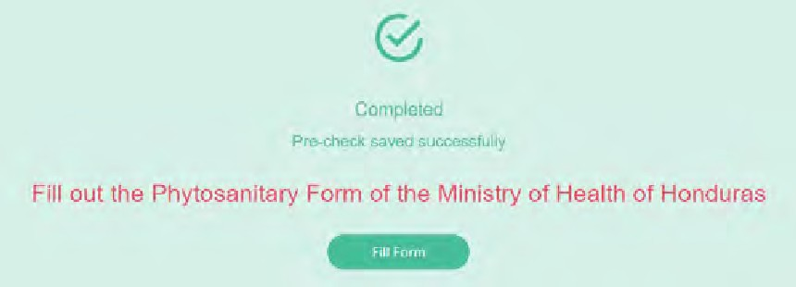

Completing the Health Form
You can switch the form to Spanish or English using the option at the top of the page (to the top right if on a PC, top center if on a phone). There is no issue switching midway through, you won’t lose any data.
Warning: In English, there are issues for the questions marked with *** below. They do not display information correctly. Issue has been reported, but in the meantime switch from English to Spanish at the top of the page to see the missing content. Switch back to English for the next question.
You can jump to any question in the form by clicking on the 3 horizontal lines in the top right corner, however all questions must be completed before you can submit.

Note: This guide only covers entry by air, although some questions will be the same. Select land or sea on the first question if that applies to you.
- Form of Entry
  - Air
  - Land
  - Sea

- Port of Arrival

English version | Spanish Version
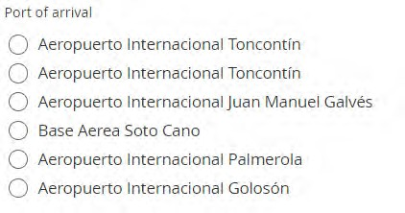 | 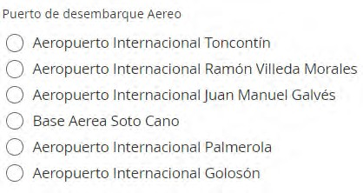
- Toncontin – Tegucigalpa (Airport code = TGU)
- Ramon Villeda Morales – San Pedro Sula (SAP)
*** In English, there is a bug whereby Toncontin shows twice. Switch to Spanish to see it correctly.
- Juan Manuel Gálvez - Roatan (RTB)
- Base Aerea Soto Cano – Soto Cano Air Base
- Palmerola – Palmerola (new airport, south of Comayagua) (XPL)
- Goloson – La Ceiba (LCE)
- Name of Airline
English version | Spanish Version
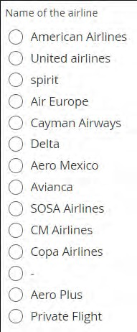 | 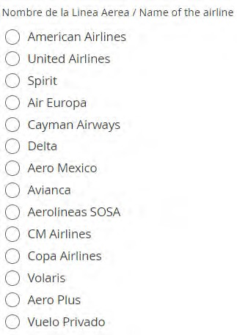
  - If your airline is not listed, select Private Flight, then select any of the 3 names listed Aeros Pinot, FLY VIP or Amerijet.
  - *** In English, Volaris is the line item below Copa airlines. Switch to Spanish to see it correctly.
- Date of arrival (yyyy-mm-dd)
- Time of arrival
- Flight number
- Seat number – Enter 0 if not yet assigned
- Responsible to Notify (pre-filled with the assigned doctor to review your form) In English, answer is missing. Switch to Spanish to see it.
- ***Date when survey is filled (yyyy-mm-dd). In English, label is missing. Switch to Spanish to see it.
- Traveler Type
- Passport Number

- Add main page of your passport – upload photo page (cannot use PDF, save as a JPG or PNG format)
- ***Date COVID-19 (test) was taken (yyyy-mm-dd) or your last vaccination.
- In English, it only asks for date of covid test. Enter date of last vaccine if that is applicable
- ***Add image of your COVID test results or copy of your Vaccination Card ((cannot be PDF format)
  - In English, it only asks you to upload a copy of your covid test. Upload copy of vaccine card if that is applicable
- First Name
- Middle Name – leave blank if not applicable
- Last Name
- Second Last Name -– leave blank if not applicable
- Date of Birth (yyyy-mm-dd)
- Gender
- Nationality
- If doing this form in Spanish, USA = Estados Unidos de America
- Profession
  - Your profession may not be listed, if you can find something similar, select that. If not, select any value.
  - Retired is not an option, so select any other value.
- Pregnant? (Question only appears if you answered “Woman” to question #19)
- Have you any signs of symptoms (of COVID-19)?
  - If yes, select all symptoms present on next question.
- ***Have you been infected with COVID-19? In English, labels are missing. Switch to Spanish to see them.
  - Yes
    - Date of Diagnosis (YYYY-MM-DD)
  - No
- *** Your actual condition (pre-filled answer, either “Asymptomatic” or “Symptomatic”. In English, answer is missing. Switch to Spanish to see it.
- Country of Residency
  - If doing this form in Spanish, USA = Estados Unidos de America
- *** Last connections (List cities you will have been) In English, label is missing. Switch to Spanish to see it.
  - List cities and countries you are travelling through to get to Honduras

Expected Address in the Country
- Type of Stay
  - House or Residency
    - Neighbourhood – e.g., West Bay, West End, Sandy Bay, First Bight, Camp Bay
    - Street name or Number (enter name of street or community)
    - House Number (if none, put n/a)
    - Other reference – any other information used to identify the residence e.g., Blue and white house on the left.
  - Hotel – enter the Hotel name.
- Department
  - Islas de la Bahia
- Municipality
  - Roatan
  - Guanaja
  - Jose Santos Guardiola
  - Utila
- Expected Departure Date (yyyy-mm-dd) Note: Question is not asked of residents.
- Email
- Phone Number

Sworn Statement
  - I certify that on this date I have completed the Health Surveillance Form….
  - I am aware that I must comply with the instructions here, maintaining social distancing….
  - I am committed to comply with the measures established…
  - Note: If any of the citizens or foreigners entering the country present the symptoms…

English version (Form ID does not populate correctly) | Spanish Version
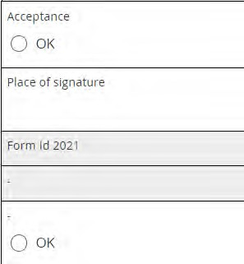
- Acceptance
- Place of signature (City, Country)
You must now switch to Spanish so the Form ID number populates correctly. It does not work in English and has been reported.

- Please take a photo of the one-time code that shows on your screen.
  - If you are using the English form, you will see the screen on the left without any Form ID.
  - Scroll to the top of the Health Form and witch to Spanish at the top right.
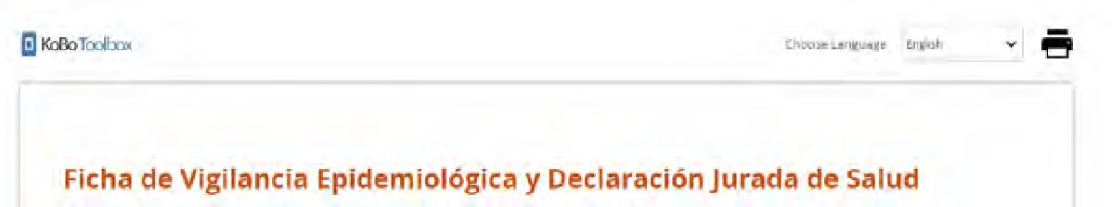

  - Scroll back down to the bottom and you should see a Form ID.
  - Using your phone, take a photo of the screen so that includes the generated Form ID #. Save this photo as you may need to show it on your trip (This step is something new so we don’t know yet, if or where it will be asked for).
  - If preferred, switch the page back to English to complete the last 2 steps.
- Have you noted the Form ID?
  - Select “OK”
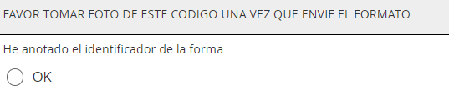

- Save Draft (Guardar borrador) or Submit (Enviar)

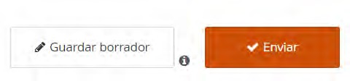

You may see this message as it queues the form for submission. Just wait a wait a few seconds until it completes the submission.
Spanish wording | English Translation
Los registros que están en cola, excepto los marcados como borrador, se envían al servidor automáticamente en segundo plano, cada 5 minutos cuando la página Web está abierta y hay  conexión a Internet. | The records that are in the queue, except those marked as draft, are sent to the server automatically in the background, every 5 minutes when the Web page is open and there is an  Internet connection.

Saving as a Draft

Warning: If you clear your browser cache, all drafts and unsubmitted final records will be permanently deleted. This will also happen if you restart your computer.
If you wish to begin completing this form in advance of getting your covid test results (which you have to upload a copy of), you can save it as a draft when you get to the end (using the 3 horizontal lines in the top right of the page and very last option, Form ID….). The draft record is stored only within the current browser and you can close this browser without losing the stored record. Draft records can be accessed by reopening this page and clicking the right close bracket symbol on the very left and middle of the screen that looks like this ], highlighted in yellow below. After clicking on the ], and then click on the right arrow in red to reload all the values entered.
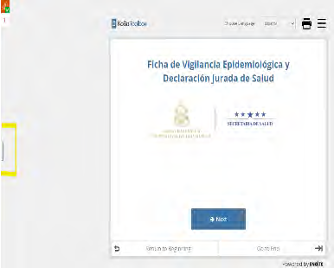
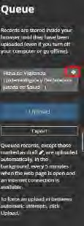

7. How to print, email, modify or delete your Pre-Check Form
If entering Honduras, print or save a copy on your electronic device. If printed, highlight your name, date of flight and pre- check number. NOTE: Electronic copy is accepted, so you do not have to print this form.
If you are leaving Honduras, completing the precheck is optional and you do not need to print it.

To print the precheck, you should have received an email to the email of the account you registered with. If you didn’t receive the precheck email, you can print it through the method outlined below:
- If you are on a computer, go to the home page (click on the house in the top left corner above the green box).
- Print the relevant form(s) using the icon with the red box show below.

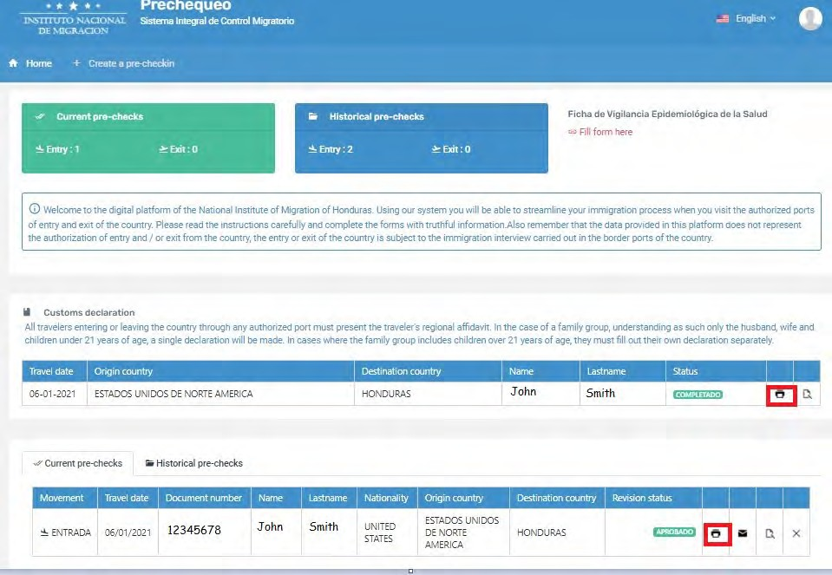
- If on a phone, you will see the image below on the left.
  - Select the 3 dots inside the green box and you will see the image on the right.
- To Print, select the printer icon.
- To email, select the envelope icon.
- To edit, select icon highlighted in green
- To delete, select the X.
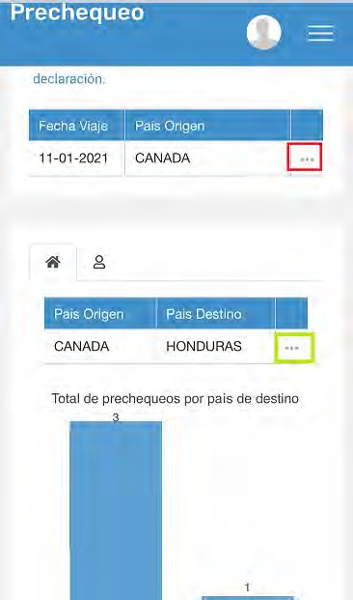
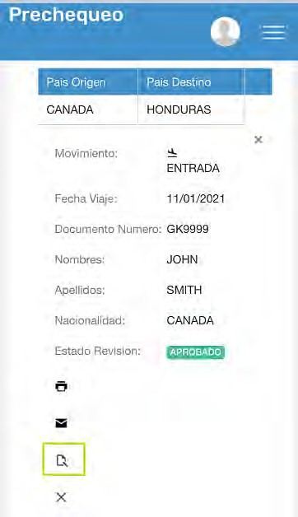

Author: Trish Symons Version History
  - - 16 Sep 2020 Initial version
  - - 20 Sep 2020 Updated with Destination States for San Pedro & Tegucigalpa. Correct reversed images for Pre-check and Affidavit.
  - – 7 Nov 2020 Updated pre-check submission page and link to Affidavit.
  - – 30 Nov 20 Corrected incorrectly rotated image
  - – 9 Dec 20 Reflect changes to site (covid questions moved to Affidavit). Add screenshots for iPhone users.
  - – 15 Dec 20 Add reminder to complete pre-check and customs form on departure. Add image of what precheck header looks like.
  - – 24 Dec 20 Add all Health Form questions and workarounds where bugs exist.
  - – 18 Mar 21 Remove requirement to print Customs Form. Update graphic on home page to select Precheck and Health Form.
  - – 15 Apr 21 Add workaround on Health form for San Pedro airport not showing for English version. Renamed document as Honduran Immigration Forms User Guide v1.0
  - – 14 Jun 21 Updated Health form to add steps on how to answer COVID testing questions if you are fully vaccinated.
  - – 15 Oct 21 Remove reference to the Customs Form which has been removed and now handed on the flight to Honduras.
  - – 23 Oct 21 Updated wording regarding upload of vaccine certificate or test.
  - – 26 Nov 21 Updated to reflect new Health Form format
  - – 06 Dec 21 Removed reference to the Health Form and updated images for registration page. Renamed as Precheck User Guide 2021-12-06
  - – 26 Dec 21 Re-added the Health Form that has been added back. Renamed as Honduran Immigration Forms User Guide 2021-12-26 04 Jan 2022 Added screenshot and translation of message when you submit the Health Form.
Added bug that English form only asks for date or covid test and upload of results. Should also say OR date of last vaccine and upload of vaccine card.

