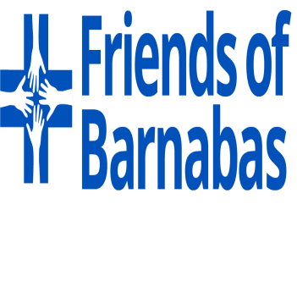

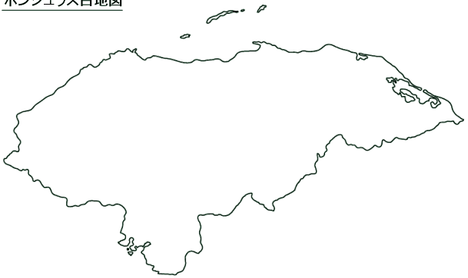
2019 Team Member Handbook

Mailing Address: P.O. Box 4804, Midlothian, Virginia 23112
Physical Address: 4001 Stigall Drive, Midlothian, Virginia 23112
Office Telephone: 804-744-5624
Fax: 804-744-6530
www.fobf.org
Table of Contents
OUR MISSION 4
OUR VISION 4
OUR BELIEF 4
OUR GOALS 4
Overview of Honduras 4
FOB Program Overview 6
WHAT FOB PROGRAMS ARE IN HONDURAS? 6
Community Health Development Program 6
HOW ARE COMMUNITIES SELECTED? 6
HOW ARE MEDICAL SERVICES PROVIDED? 6
WHAT TYPE OF EDUCATION IS PROVIDED? WHAT ABOUT OTHER COMMUNITY NEEDS? 6
Extended Care Program 7
WHAT IS ECP? 7
Early Childhood Development Program 7
WHAT MORE CAN WE DO FOR CHILDREN? 7
Little Hearts Project (a partnership with Ruth Paz Hospital) 7
WHAT IS THE LHP? 7
My Role As A Mountain Medical Team Member 8
GOOD HEALTH 8
IMMUNIZATIONS 8
MOSQUITO-BORNE DISEASES - Read Carefully! 8
PASSPORT 9
INSURANCE 9
REGISTERING WITH THE US EMBASSY 9
PACKING LIST 10
CREDIT CARD USE 11
E-JOURNALS 11
ACCOMMODATIONS 11
MY ROLE ON THE TEAM 11
SPECIAL REQUIREMENTS FOR MEDICAL PROFESSIONALS 11
WHAT DO I DO IF…? 12
Fundraising 101 12
START EARLY AND DETERMINE YOUR FUNDRAISING GOAL 13
BREAK DOWN YOUR GOAL 13
WHAT TO DO 13
WHAT NOT TO DO 13
WHO TO ASK 14
HOW TO ASK 14
DIRECT SOLICITATION ONE-ON-ONE 14
SAMPLE IN-PERSON/PHONE SOLICITATION 14
DIRECT SOLICITATION BY MAIL 15
SAMPLE LETTER/E-MAIL 15
OTHER IDEAS 16
DIRECT SOLICITATION TO A GROUP 16
FUNDRAISING EVENTS 16
SETTING UP A FUNDRAISING PAGE ON MIGHTY CAUSE - It’s quick and easy! 16
GETTING STARTED 16
WHEN YOUR TRIP IS OVER, PLEASE HIDE/DELETE YOUR MIGHTY CAUSE PAGE 16
FACEBOOK FUNDRAISING - It's easy to create a fundraiser, share it with friends and reach your goal! 17
Volunteer Safety and Security Policies 17
DAY-TO-DAY SAFETY: WHERE WE WORK 18
RISKS AND SAFETY CONCERNS 18
HEALTH 18
NATURAL DISASTERS 19
MAN-MADE RISKS 19
RISK ASSESSMENT AND REDUCTION 19
HEALTH 19
NATURAL DISASTER RISKS 19
MAN-MADE RISKS 20
FRIENDS OF BARNABAS SAFETY POLICIES 21
LOGISTICS 21
DAY-TO-DAY ON-SITE SAFETY 21
HEALTH EMERGENCIES 21
NATURAL DISASTERS 22
POLITICAL AND CIVIL UNREST 22
OFF-SITE POLICIES 22
LIMITATIONS 22
Gift Giving Policy – please read carefully 23
What Is Required of Me? 24

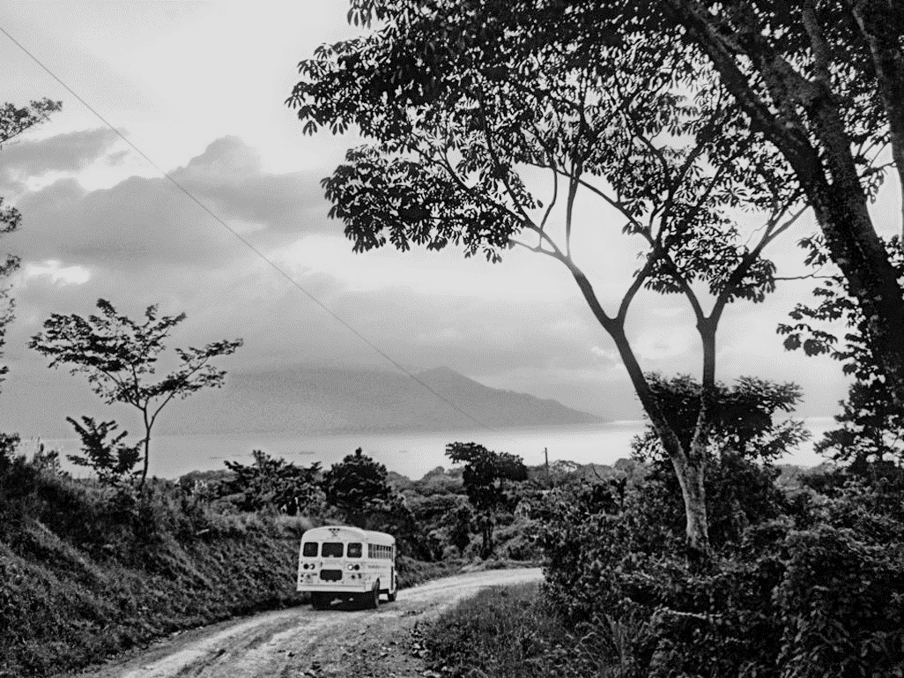

OUR MISSION
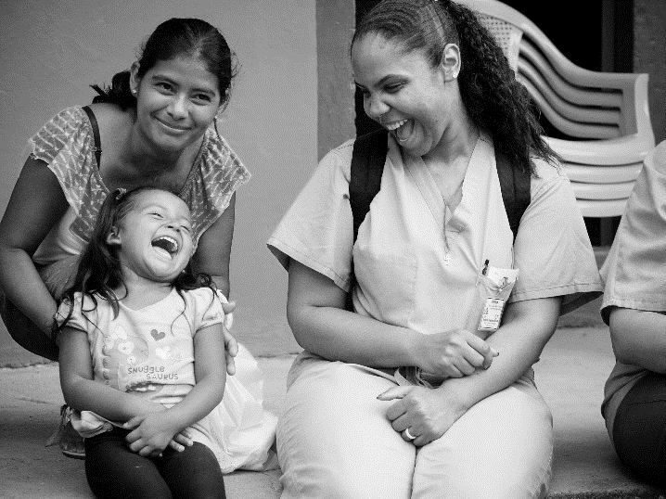
Our mission is to improve the lives of impoverished children in Honduras by providing high quality sustainable health care and enabling communities to become self-sufficient through health-related training and education.

OUR VISION
As a result of our work we envision the following for Honduras:
- Well educated Honduran health care providers
- Reduced incidence of birth defects and childhood mortality and morbidity
- Communities educated on proper health care and training
- A large force of trained volunteers providing high quality health care and training
- Access to quality health care for the impoverished
- Healthier children and communities

OUR BELIEF
We are a faith-based organization that believes that the love of God is best expressed through the hands and hearts of God’s people in the care and service of others.

OUR GOALS
- Promote sustainable changes and improve the overall community health of poor rural communities in Central Honduras which currently have no access to health care services by providing comprehensive health care services, training and education.
- Provide health care for children with special needs beyond the care that the mountain medical teams and local health clinics can provide.
- Create, support and advance sustainable pediatric surgical programs in Honduras.
- Develop and maintain high quality partnerships with other organizations with similar interests.
- Increase philanthropy/giving in the US and Honduras to support the goals of the organization.
- Track and understand the impact of the work of the organization.

Overview of Honduras
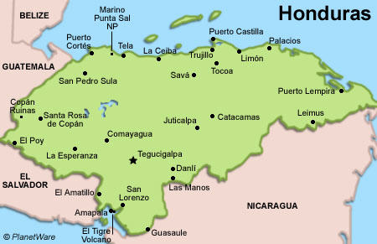
Honduras is a democracy with a developing economy bordered by the Caribbean Sea to the north and the Pacific Ocean to the south. Honduras is one of the poorest countries in the Western Hemisphere. More than half of the population lives in poverty and per capita income is one of the lowest in Latin America. Poverty rates are higher among rural and indigenous people.
The national language is Spanish and the climate is generally temperate, with dry and wet seasons. The terrain includes mountainous areas, coastal beaches, and jungle lowlands. The majority of the work of the Friends of Barnabas takes place south of San Pedro Sula and west of Tegucigalpa, in the surrounding areas near Lago de Yojoa.
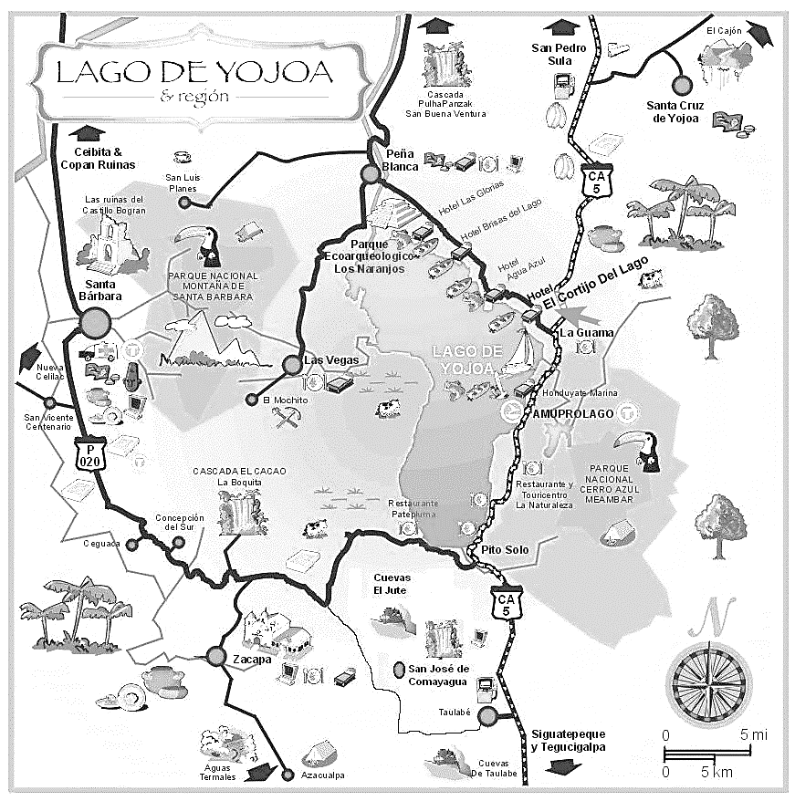
While FOB programs impact the lives of Honduran families nationwide, our day to day operations and outreach focus on the Central Highlands of Honduras. This area is one of the most depressed regions in Honduras because of poor road conditions and lack of infrastructure. Seventy percent of the population in Honduras live below the poverty line, and fifty-four percent live in extreme poverty. Fifty percent of all children in the Central Highlands are malnourished. Many others suffer from disease and birth defects.

FOB Program Overview

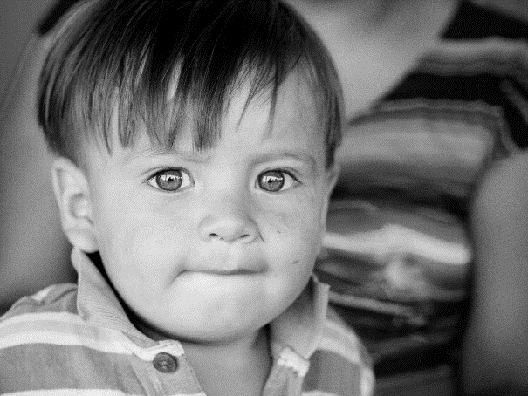
WHAT FOB PROGRAMS ARE IN HONDURAS?
- Community Health Development Program
- Extended Care Program
- Early Childhood Development Program
- Little Hearts Project (in partnership with Ruth Paz Hospital)
Friends of Barnabas programs address many components of the Honduran health care system, from community-based initiatives to system wide endeavors.
These programs:
- Provide health care services to those without access,
- Teach preventative health education,
- Empower and improve the capacity of local healthcare providers,
- Offer an unprecedented Extended Care Program for children with serious medical needs,
- Promote healthy growth and development for children 0-5 years old,
- Provide surgeries utilized by children throughout Honduras.

Community Health Development Program

HOW ARE COMMUNITIES SELECTED?
Twenty-five to thirty communities are selected annually based on the following criteria:
  - Community has no health center and/or limited access to a health center.
  - Community has a lack of infrastructure and/or is without sanitary systems and clean drinking water.
  - Community is not presently served by others offering services which would duplicate FOB’s efforts.
  - Community has been identified as poor and has significant health care needs as presented through poverty studies and/or FOB’s previous work experience in the area.
  - Reliable access for security purposes exists in and out of the community.
  - Community leaders express genuine interest and commitment to the program and agree to sign a formal document of partnership and commitment.

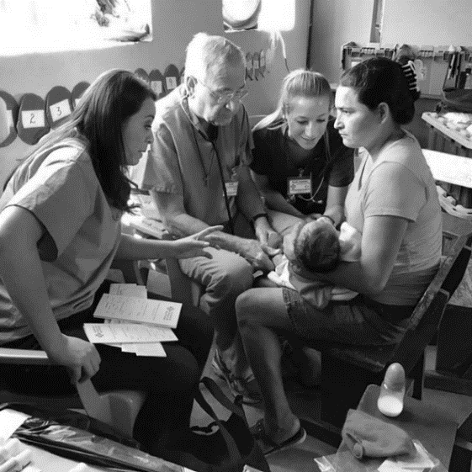
HOW ARE MEDICAL SERVICES PROVIDED?
Health care services delivered by 12 traveling Mountain Medical Teams, serving each community twice a year, provide:
  - general medical care,
  - vision care for adults and vision screening for children 2-18 years old.
  - dental care,
  - services for children (anti-parasite medications, fluoride),
  - prenatal and child vitamin distribution,
  - referrals for other FOB services.

WHAT TYPE OF EDUCATION IS PROVIDED? WHAT ABOUT OTHER COMMUNITY NEEDS?
Health committees are established in each community and trained in preventative health practices. A 3-5 year program is implemented with monthly health lectures. Workshops focus on general health education, reproductive health, general hygiene and the environment, women’s health, and specific community needs. Health Volunteers are identified, trained, and empowered with first aid kits. Advanced training is provided for midwives. Partnerships are formed with other organizations to meet the needs of stoves, wells, latrines, etc.

Extended Care Program

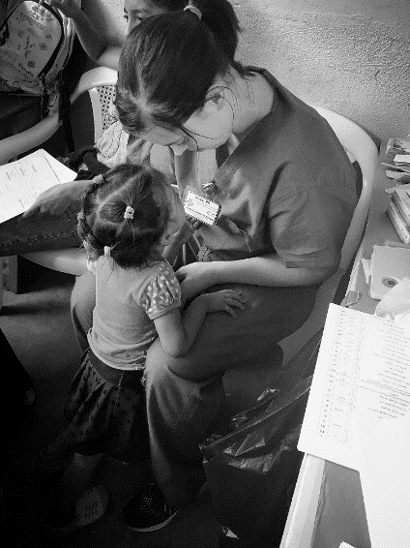
WHAT IS ECP?
The Extended Care Program was developed for children whose medical needs go beyond care provided by field clinics. Children referred to this program suffer from cardiac defects, neurological disorders, cleft lip and cleft palates, clubfoot, and other defects and illnesses. Care is provided through FOB’s Barnabas House and also through a network of partner organizations.
Referrals to ECP are generated from Mountain Medical Teams as well as NGOs, hospitals, and agencies throughout Honduras. Partner facilities with various medical specialties are utilized whenever possible and children enrolled in the ECP are provided with patient case management; home visits by FOB’s physician and nurses; transportation to appointments with specialists and hospitals throughout Honduras; medications and medical equipment; and treatments and surgeries deemed necessary.
Educational workshops for parents and caregivers of special needs populations are held through the Extended Care Program, such as coping with neurological disorders, palliative care, nutrition, support for families of children with Down’s syndrome, and medication safety and administration.

Early Childhood Development Program

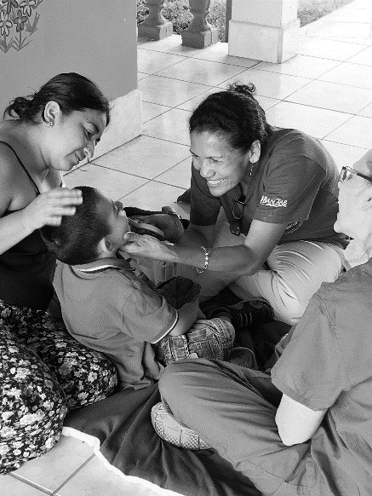
WHAT MORE CAN WE DO FOR CHILDREN?
FOB’s Early Childhood Development Program is centered on the education of developmental delays, the use of screening tools in communities, and the value of practical therapy methods. Studies show that the stress of poverty is a risk factor for poor brain development, and early intervention can be a child's best chance to thrive.
FOB is working with Honduran medical and development professionals, community health volunteers, teachers, and parents to increase early diagnosis of delays and support appropriate growth and development.
Program goals include integrating the use of screening tools in FOB communities and increasing their use with the ECP; referring children identified with delays for occupational therapy, speech therapy, and physical therapy through our Extended Care Program; increasing early diagnosis of developmental delays by increasing awareness in the medical community; and advancing the skills of local NICU medical professionals. Community workshops, screenings, and data collection are ongoing, and a yearly Child Development Team provides continuing education and support. To date, nearly 300 children are being screened in our partner communities.

Little Hearts Project (a partnership with Ruth Paz Hospital)

WHAT IS THE LHP?
The Little Hearts Project (LHP) is a comprehensive pediatric cardiac project created in partnership with local Honduran hospitals and health care providers. FOB worked to establish the project for more than a decade with the support of yearly screening teams as well as interventional and surgical teams and by training the first, formally trained, pediatric cardiovascular surgeon in Honduras, Dr. Victor Paz. In 2015, the first Honduran pediatric cardiac surgical ward and ICU was opened and staffed for year-round surgeries at Ruth Paz Hospital. FOB remains a partner in the LHP, providing support and educational opportunities, as needed.
Along with children from throughout Honduras, many patients in FOB’s Extended Care Program benefit from the Little Hearts Project. For these children, FOB provides case management services as well as pre-operative, post-operative, and follow-up care.

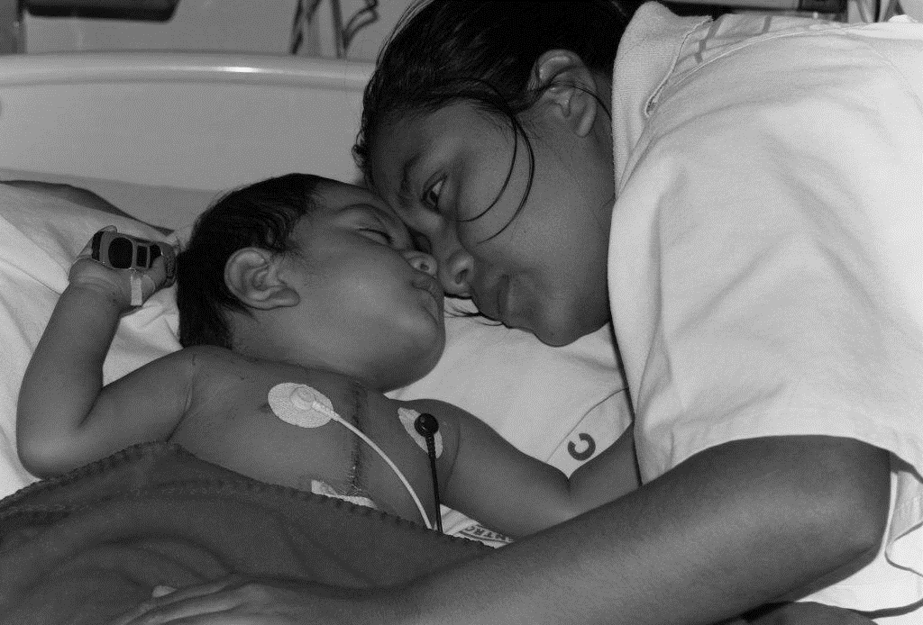
My Role As A Mountain Medical Team Member

GOOD HEALTH
Travel in Honduras can be strenuous and unpredictable at times. Bus rides can be quite rough and team members are occasionally required to hike in the mountains. During much of the year, it is extremely hot and the working days are long. You must be in EXTREMELY good physical shape in order to be a contributing member of an FOB team. Please discuss these conditions with your physician before committing to a team.
Travel Funds
Each team member is required to pay $1965 toward their mission trip. All Friends of Barnabas volunteers traveling to Honduras MUST have their travel contribution PAID IN FULL two weeks prior to the date of departure. No team member will be allowed to travel if travel contributions have not been received by the FOB Central Office in full two weeks prior to the date of departure. Should a team member fail to adhere to this policy, travel will not commence, and FOB’s no refund policy remains in effect.

IMMUNIZATIONS
The following table lists the most often recommended immunizations and preventive medicines for travel to Honduras. However, you should seek the advice of your local physician for specific recommendations. Upon selection as a team member by your Team Leader, this activity must be an immediate priority.

Item | Recommendation
Routine Vaccines | Make sure you are up-to-date on routine vaccines before every trip. These vaccines include measles-mumps-rubella (MMR) vaccine, diphtheria-tetanus-pertussis vaccine, varicella (chickenpox) vaccine, polio vaccine, and yearly flu shot.
Hepatitis A | Injection consisting of two shots, five months apart; good for ten years.
Hepatitis B | Injection consisting of three shots, the first two given one month apart, followed in six months by the third; a booster is recommended every ten years.
Malaria Prevention *** | Needed each trip; multiple options are available.
Traveler’s Diarrhea | Needed each trip; Cipro prescription for 5-7 day course, or as your doctor recommends.
Yellow Fever | Single dose, injection, good for 10 years, need to administer 10 days before travel
Typhoid | Single dose, oral or injection; every two years..
CDC recommendations | May include more than what is contained in this list.

***Highly encouraged.
MOSQUITO-BORNE DISEASES - Read Carefully!
Due to the high risk of mosquito-borne diseases in Honduras, travelers are encouraged to wear long-sleeved shirts, pants, and socks, as weather permits. Also, insect protection containing DEET (25-50%) is strongly encouraged. We VERY STRONGLY suggest that you use a bug spray or wipes with DEET each day, reapplying throughout the day to all exposed skin areas and applying after the use of sunscreen. (REI and Dick’s Sporting Goods carry long lasting bug repellant wipes.) Be careful with products that contain extremely high DEET percentages, as these may irritate your skin.
Significant Malaria, Dengue, Chikungunya and Zika activity continues in Honduras. Symptoms generally appear within a week of exposure. We encourage you to visit the WHO website to learn about the symptoms of each disease. http://www.who.int/neglected_diseases/vector_ecology/mosquito-borne-diseases/en/
Should you have symptoms of any of these illnesses after returning to the US, please see your primary care physician and contact FOB’s Medical Coordinator at patti@fobf.org.

PASSPORT
Secure your passport NOW! If you have one, find it. Check the date, making sure that it is valid at least 6 months past your return date. If you do not have your passport, please start the application process as soon as possible. Please submit to your Team Leader a photocopy of your passport photo page (in color if you are a medical professional).

INSURANCE
The Friends of Barnabas provides medical travel insurance through United Methodist Volunteers in Mission (UMVIM), Southeastern Jurisdiction. Please note the following procedure to ensure that each team member has adequate insurance.
- The FOB Travel Coordinator will register the team with UMVIM. Please don’t register yourself.
- After the team is registered, all team members including the Team Leader will get an official email notice from UMVIM with a link to fill out a Missioner Profile and Release of Claim Form. Once notified, the form should be completed and returned online within two days of receipt from UMVIM. The UMVIM email will come from SEJinfo@umvim.org.
If a team member does not have an email address, the FOB Travel Coordinator can register that member on their behalf. The insurance provided by FOB through UMVIM begins on the day of travel and covers the following:
- accident and medical coverage of $25,000;
- a pre-existing condition waiver up to $15,000;
- medical evacuation and repatriation up to $100,000;
- lost luggage up to $250;
- trip interruption in the event of the death of an immediate family member or serious damage to the insured member's home up to $5,000;
- emergency medical reunion;
- the return of a minor child.

REGISTERING WITH THE US EMBASSY
The process of registering with the US Embassy in Honduras is a very important part of our security protocol and a requirement for all team members.
- Go to https://step.state.gov/step/ to enroll in the Smart Traveler Enrollment Program (STEP) of the US Department of State
- If you have not previously created a STEP account, go to “Create Account” and click on “Create Individual Account” and follow the directions.
- If you already have an STEP account, sign in and click “Add a Trip”
- You will follow a Wizard Guide through the process.
- Click “Next”.
- Complete the “Destination Information”
  - Country: Honduras
  - Local Embassy or Consulate: San Pedro Sula
  - Type of Visit: One Time Visit
  - Destination Date of Arrival and Departure: Insert your team’s dates
  - Purpose of Visit: Mission Trip
  - Address:
    - Destination Type: Other
    - Address Line 1: Casa de Bernabe
    - City: Peña Blanca
    - Province: Cortes
    - Country: Honduras
    - Phone Type: Other (011-504-9733-5172) (This is the team phone.)
- Click “Next”.
- If a family member is traveling with you, please complete the “Travelers” section and then click “Next”. If not, click “Next”.
- If you would like to have travel updates, make sure that your email and country selection are made in the “Travel Information Email Distribution List”.
- Don’t forget to check the box if you want to receive emails about travel updates.
- Click “Next”.
- Read any Public Announcements and click “Next”.
- You will see the page to confirm your trip.
- Click “Finish”.
- You will be returned to your Profile page. Make sure all information is correct.
- Click Logout on tab above your information.

PACKING LIST
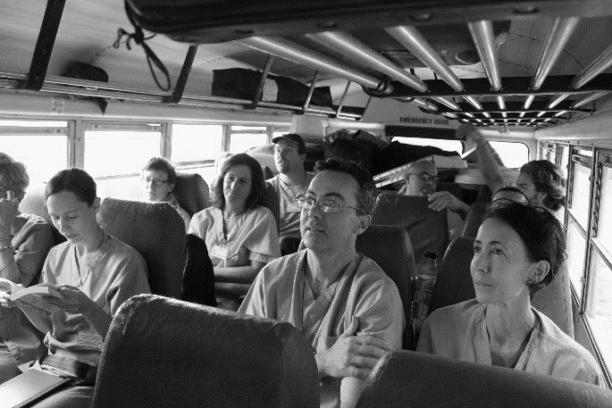
You must pack all personal items in your carry-on luggage. Remember that you may carry one carry-on bag (size varies by airline) plus one personal item, such as a purse, a small backpack, or a tote bag. FOB will provide your team with 1-2 duffels for team member footwear and liquids. Upon departure, if you wish to check your personal baggage, you are responsible for paying any baggage fees ($25-can only use a credit card).
Sample Packing List
High Priority Items
  - Passport (as well as a photocopy of your passport in your carry-on)
  - Driver’s License
  - Pocket Cash $100-$150 US is plenty. Keep only needed items in your wallet. You will be able to exchange $50.00 into lempiras once you arrive. Please bring bills other than $20s, as it can be problematic to use $20 bills in Honduras.
  - Personal medications
  - LEAVE JEWELRY AT HOME

Personal Items
  - An extra set of prescription glasses or contact lenses (if needed)
  - Sunscreen and Insect repellant* (*suggested with 25-50% DEET)
  - Hat and Sunglasses
  - Flip flops/shower shoes
  - Water bottle - FOB provides clean water
  - Toiletries
  - Pepto Bismol/Immodium
  - Toilet Paper – In Honduras, this goes in the TRASH CAN, not the toilet.
  - SCRUBS WILL BE USED ON WORK DAYS (You will be loaned three sets upon arrival. Laundry services will be available.)
  - Clothes for tourist activities and church (Casual clothes are fine, including shorts. Review Safety and Security Policies regarding appropriate clothing.)
  - Good work shoes – already broken-in, hard-sole hiking boots are best
  - Lightweight rain poncho/light jacket
  - Waterless hand cleaner/wet wipes
  - Net laundry bag/plastic bag for dirty clothes
  - Plastic bags for trash disposal

Other suggested items
  - Journal/notebook and pen
  - Camera
  - Snack foods (no meltables)
  - Pocket English/Spanish dictionary
  - Small flashlight (and extra batteries)
  - Reading material

Medical Professionals
  - Please bring your own stethoscope and otoscope.
  - Bring instruments/equipment (not medications) that you would be uncomfortable without.

CREDIT CARD USE
Credit cards can be used in Honduras in the airport and at some restaurants and select stores. Having a credit card with you for emergency situations is suggested. PLEASE remember to call your credit card company prior to departure and let them know you are traveling out of the country. Debit cards cannot be used in emergencies.

E-JOURNALS
Friends and family can follow your experiences through team e-journals. Published daily, technology permitting, the e-journals can be received via email or read either on FOB’s website (www.fobf.org - Barnabas Blog) or on FOB’s Facebook page. New team members should sign up for e-journals as soon as possible. If someone wishes to receive the e-journals via email, please ask them to contact FOB’s Development Coordinator at ashleigh@fobf.org.

ACCOMMODATIONS
Mountain Medical Teams spend the majority of their time at Alfredo’s House within the FOB complex in Peña Blanca, approximately an hour and a half south of San Pedro Sula. Team members share rooms equipped with air conditioners and fans and utilize hall bathrooms with showers. Linens and pillows are provided. A common area allows teams to fellowship and eat together. Delicious local foods and dishes are served by FOB cooks.

MY ROLE ON THE TEAM
There are various different roles in which you can serve, depending on your skills and interest. We’ll ask you to take on at least one, if not multiple roles depending on the make-up of your team. Most FOB mission teams have around 15 members.
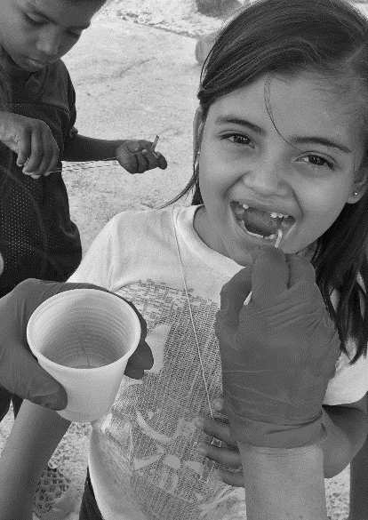
- Devotion Leaders plan or assign devotions for the week.
- While all team members are asked to participate in fundraising, one team member will be the Fundraising Leader and will organize fundraisers and manage the team’s efforts toward their fundraising goal.
- Physicians, physician assistants, nurse practitioners, and registered nurses will most likely staff a general clinic station with the help of a translator. Upon occasion, physicians serve as a floating consultation, supporting all clinic stations. Medical professionals may be asked to support other clinic areas.
- Fluent Spanish speakers and local Honduran translators will be assigned to individual stations. FOB staff determine the clinic area in which translators serve.
- Dentists, oral surgeons, and dental hygienists will work with a local Honduran dentist in the dental clinic.
- Optometrists and ophthalmologists will work with FOB staff in the vision clinic.
- If available, EMTs can help the team by managing triage stations.
- A Photographer and Team Journal Keeper are needed to capture the stories and special moments of the week.
- A Team Treasurer will keep team funds and be responsible for the team accounting.
- For non-medical or non-Spanish speakers, there are a wide variety of jobs to do, such as providing vitamins, anti-parasite medications, and fluoride treatments to children; assisting in the dental and vision clinics; and more.

SPECIAL REQUIREMENTS FOR MEDICAL PROFESSIONALS
Medical professionals are required to submit a color copy of their passport and a copy of their current medical license to their Team Leader. All physicians must also submit the following: Curriculum Vitae and copies or photographs of all diplomas. These materials should be submitted no later than 45 days prior to departure. The designated Medical Team Leader should reach out to FOB’s Medical Coordinator (patti@fobf.org) as soon as he/she joins the team.

WHAT DO I DO IF…?
…there is a crisis in my family back at home in the US? In cases of EMERGENCIES, the quickest way for your family to get a message to you is to call FOB’s Central Office (804-744-5624), Monday-Friday from 9am-5pm. After working hours, family members may call FOB’s President (804-338-0163). Our US staff members have the best resources to reach our Honduran staff members who can quickly get you to a phone to call home. Please be courteous and instruct your family members to utilize this in EMERGENCIES only.
…I lose my passport? If you are still in the US, call FOB’s Travel Coordinator as soon as you realize that your passport is missing, 804-744-6518, Monday-Friday from 9am-5pm. After working hours, call the Travel Coordinator at 804-873-1451. If you are in Honduras, please notify FOB’s Honduras Country Director. We can advise you as to how to secure a new passport and we can help you do it quickly! Team Leaders and the US Office staff keep a copy of your passport in case you need it, but you should also carry a photocopy in your backpack.
…something happens and I cannot make it the day I am supposed to depart? Call FOB’s Travel Coordinator as soon as possible, 804-744-6518, Monday-Friday from 9am-5pm. After working hours, call the Travel Coordinator at 804-873-1451. Actions need to be taken to cancel your ticket BEFORE the actual time of departure. We can help save the ticket and there is always a possibility of traveling to Honduras on a different day.
…I need to call home or send an email? Have no fear! Our teams are given a team mobile phone and can use it to check in at home. Obviously, brief conversations are most ideal as the intent is to check in and not catch up. Alfredo’s House is set up with a wireless internet connection as well as a computer for team use, so feel free to check your email and send notes home.
…I have dietary restrictions? Please make a note of this on your Team Member Information Form and also discuss your specific needs with your Team Leader. FOB’s Central Office staff will work with our Honduras Country Director to determine if we can accommodate your needs, if you need to pack special food items for yourself, or if your needs cannot be met and thus, an FOB trip might not be appropriate for you. FOB can accommodate some but not all dietary restrictions. Please be clear about your needs and develop a plan as to how they will be met prior to joining a team.

Fundraising 101
Congratulations! You have accepted an incredible opportunity to serve children and families in one of the poorest countries in the world by participating in a Friends of Barnabas team. We are grateful for your upcoming service to the families of our communities in Honduras.
The $1965 minimum donation amount in honor of your trip is required to cover the expenses for your trip and stay. Have no fear! Many Friends of Barnabas volunteers have raised well above the necessary funds for their trips and even found the fundraising to be a very rewarding part of their experience. The more you are able to raise, the greater the impact on the communities you will visit!
To go to Honduras with a Friends of Barnabas team is exciting; but it’s even more exciting to know that when you leave to go home, the work continues. Your fundraising efforts will have a dramatic impact on the lives of friends you are soon to meet.
Think of it as raising money NOT for yourself, but instead for the people of Honduras who benefit from Friends of Barnabas’ service to remote communities, and you may find raising money is an easier task. Fundraising is an opportunity to energize others about your upcoming trip and to play an important part in your mission. Not everyone you know could go to a developing country, but everyone can play a role in what you’re doing by helping to get you there. Let your friends, colleagues, and all those in your community know about the amazing work you are about to do!
The most important part of a successful fundraising effort is your own enthusiasm for your journey. If you need more help, ideas, or encouragement, just let us know. Contact FOB’s Development Coordinator at 804-744-5624 or ashleigh@fobf.org if you have any questions or need suggestions on creative ways to reach your goal.

START EARLY AND DETERMINE YOUR FUNDRAISING GOAL
Before you start fundraising, you’ll need to determine how much money you need to raise. Estimate how much you will be able to personally contribute. It will be easier for you to ask potential donors for help if they understand that some of your own funds will be allocated towards the cause as well. When requesting money from prospective donors, you could say, “I have already contributed _____ dollars, but volunteering in Honduras is costly, and I need to raise _______ more.”

BREAK DOWN YOUR GOAL
Reaching your goal is easier if you break it up and it will seem easier. Following are some suggestions, tools, and tips to get you started in raising funds:
personal donation (1 x 500) $ 500
church offering/donation in honor of your trip (1 x 500) $ 500
ask 2 local businesses for $100 (2 x 100) $ 200
ask 5 friends/family for $73 (5 x 73) $ 365
ask 4 friends/family for $50 (4 x 50) $ 200
ask 10 friends/family for $20 (10 x 20) $ 200
$1965
Adjust this sample to whatever suits you and your situation. If you can afford more yourself, great. If your church can give more, even better! You could hold a bake sale, put a donation jar on your desk at work and share at a staff/team meeting about your trip, or you can ask more or less people for the higher or lower amounts. This just gives you an idea of how to break down your goal into more manageable pieces.

WHAT TO DO
- Ask for money! The first rule in fundraising is if you don’t ask for money, you won’t get it.
- Be confident in your mission! You are committing yourself to an outstanding cause and should convey your energy and excitement about the trip to your donors.
- Thank your donors. It is important to send sincere thank you letters in a timely manner. Even thank those who don’t contribute, for taking the time to listen. Donors for your trip will also be thanked by Friends of Barnabas when they contribute to your trip or team.
- Learn about Honduras and Friends of Barnabas at www.fobf.org and promote the website as a source of information for your donors. Beautiful color brochures about FOB are available for you to use. Ask your Team Leader or call the FOB Central Office.
- Include information, pictures, your own personal experiences (for repeat team members), and specifics about the programs that you’re going to serve. If you need materials, just let us know. We are here to help you exceed your goal!
- Suggest a definite, realistic amount to each donor. It makes it easier for donors if they do not have to select a figure on their own, so ask for an appropriate amount that matches each donor’s resources.
- Leverage social media and share information about your mission and financial needs on Facebook, Twitter, Google+, etc.
- Set up a Razoo fundraising page. The more people you contact, the larger your giving base will become, and the easier it will be to reach your goal. Instructions follow.
- Carry donor cards or envelopes with you. You never know when there might be an opportunity to ask!
- Ask a successful fundraising members of your team or FOB for help. If you are having difficulties, ask what others have done to be successful or call Ashleigh at FOB for suggestions and assistance.

WHAT NOT TO DO
- Don’t wait until the last minute. It takes time for people to consider your request and make a decision.
- Don’t get discouraged. Not everyone will give to your fundraising campaign. If you receive a “no” at least you had the opportunity to let someone know about the important work you are about to do.

WHO TO ASK
- Family members & friends
- A special offering or a grant from your church
- Church groups - Sunday School classes, women’s/men’s groups
- Your work
- School groups
- Clubs, organizations, local businesses

HOW TO ASK

DIRECT SOLICITATION ONE-ON-ONE
The most effective way to ask is in person. A direct ask is a one-on-one conversation discussing your trip either in person or on the phone. During the meeting or phone call, you will give them solid reasons to support your cause, and end in a formal request for support by asking them to financially support your mission.
Just like asking by mail, it is important to be heartfelt but brief, ask for a specific amount, give clear instructions, and describe exactly what their donation will support.
It is important to always have options in mind, so that if the donor is unable to contribute the donation you first suggested, they still can help with your efforts in a smaller, or different way. Share with your donor that every little bit helps and gets you closer to your goal of going to Honduras.
The success rate for a direct, in-person ask is much higher than other forms of fundraising, because it’s harder for your potential donor to say no! So while it may be the most intimidating, it will reap a greater reward.

SAMPLE IN-PERSON/PHONE SOLICITATION
Hello, this is [Name].
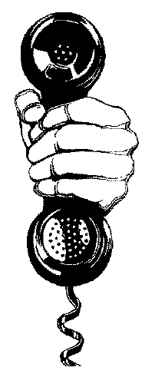
I have been given the unique opportunity to volunteer with a Friends of Barnabas mission team in Honduras, one of the poorest countries in the world. I will participate in a medical mission. My team will be providing general health care, giving out vitamins and medicine, and helping in the dental or vision clinics. I will work alongside the staff on the ground at the Barnabas House in Peña Blanca to help them bring hope to the children of Honduras.
Being part of this deserving mission is exciting, but also expensive, which is why I am contacting you for financial support. I would like to ask you to join me on my journey by supporting my fundraising efforts. A gift of [$50] will go a long way and make a tremendous impact. Is this something you would like to consider or learn more about?
(If the potential donor agrees to make a donation in the amount you request, instruct them to write a check to “Friends of Barnabas” or use FOB donation cards, available from the FOB Central Office. Contact ashleigh@fobf.org for details. If the conversation is not in person, offer to mail them the donation card and a self-addressed envelope.)
(If the potential donor cannot donate the initially requested amount, be prepared with a smaller amount, and tell them that every little bit helps.)
Thank you for your interest. A donation in any amount is appreciated.
If you are unable to donate personally and still want to help out, could you put me in contact with any individuals or organizations you are affiliated with that might contribute? Thank you for taking the time to listen, I appreciate your support.

DIRECT SOLICITATION BY MAIL
- Be yourself – These letters/emails are to people you actually know. Make sure it sounds like something you would say.
- Keep it short and sweet. One page is plenty.
- An easy, three step outline for a donation letter is an opening personal anecdote, a description of the financial request and what it will support, and an explanation of what the donor’s personal contribution would make possible in Honduras.
- Include pictures, especially if you have travelled with Friends of Barnabas before and have pictures of yourself in action.
- Be direct. Let your reader know up front that you are asking for their support. Phrase your financial request clearly and politely, i.e. “In order to serve in Honduras this year, I will need to raise at least $1965. I am writing to ask you to consider making a contribution to my effort.”
- Give clear instructions on how to contribute to your mission---who and where to send it to, and by what time. Request that all checks be made out to Friends of Barnabas. Donations can be given or mailed to you and then you pass them on to us, or they may be mailed directly to our office. Have your donor write “In Honor of <Your Name>” on the memo line of the check. Please be sure to send a list of names, addresses, and contribution amounts for all cash donations. Be sure to share with your supporters that donations are FOB tax-deductible.
- Give a deadline - most people respond well to a deadline, as long as your deadline isn’t last minute!
- Include a pre-addressed envelope and donation slip for the donor’s convenience, and to ensure that the contributions reach the correct address.
- Ask for a specific amount of money. For instance, “a $50 gift will go a long way.”
- Even if you type a “form” letter, personalize it with a handwritten note at the bottom of the page. This shows that you put thought and time into the letter and reminds donors of their personal connection with you. Even brief notes such as “Hope you can help. Looking forward to seeing you in church next Sunday” can make a significant difference in your response rate.

SAMPLE LETTER/E-MAIL
Dear ________________________,
I have been blessed with the opportunity to travel to Honduras this year and I would like to invite you to join me on this extraordinary experience. In [Month], I will be departing on a mission trip to Peña Blanca, Honduras, where I will be volunteering with Friends of Barnabas.
Honduras is one of the poorest countries in the world. More than half of the people live in poverty and over half of that half live in extreme poverty. The country is also prone to hurricanes and flooding, particularly in the areas close to the Caribbean coast.
The mission of Friends of Barnabas is to improve the lives of impoverished children in Honduras by providing high quality sustainable health care and enabling communities to become self-sufficient through health training and education.
As a team member on a Friends of Barnabas trip to Honduras, I will serve on a [medical mission team]. Our team will travel to remote villages in the mountains of rural Honduras, providing health care to children and their families. We will provide general health care, dispense vitamins and medications, and offer dental and vision care. These children will have access to good health care which would be difficult or impossible to receive without us coming to them. I hope to make as big of an impact on the people I serve as I know they will have on me.
I would truly appreciate your financial support for me to join this mission trip. I will need to raise $1965 for Friends of Barnabas in order to be eligible to participate. A gift of [$50] will go a long way and make a tremendous impact.
All donors to the mission will receive blog updates from my team while we are in Honduras, so they can be a part of this experience from afar. If you would like to support the mission, please fill out the attached donation card and send it to me at [address] by [specific date]. Please make your check payable to “Friends of Barnabas.” Your contribution to Friends of Barnabas is tax-deductible and you will receive a receipt for your tax records.
If for any reason I am unable to participate in the trip, your donation will be used to support the programs of Friends of Barnabas.
If you have any questions about the mission, I would love to hear from you--please contact me at [phone number] or [email address.] I am so grateful for your friendship and encouragement. Thank you and may God richly bless you as you consider your support for this mission trip!
Sincerely,
[Name]

OTHER IDEAS

DIRECT SOLICITATION TO A GROUP
The best thing about requesting support from a group of people is that the small amounts of support that each person contributes add up to a large sum. Take advantage of community events, family gatherings, church services, etc., and reach out to large, new networks of people.

FUNDRAISING EVENTS
In the past, volunteers have created sports sponsorships where people pledged donations for each mile of a marathon; organized bake sales or car washes; sold jewelry; and held percentage nights at restaurants.

SETTING UP A FUNDRAISING PAGE ON MIGHTY CAUSE - It’s quick and easy!
By using MightyCause.com, your team can have individual fundraising pages as well as a team page. Using fundraising tools online can boost your efforts and build excitement for your upcoming mission. Go to www.mightycause.com You will be asked to log in or sign up. If you have used Mighty Cause (formerly Razoo) in the past, use the same log-in information. If you are new to Mighty Cause, it is easy to create an account with your email address.

GETTING STARTED
- Search for Friends of Barnabas in the search bar or go to:
https://www.mightycause.com/organization/Friends-Of-Barnabas-Foundation
- Click the “Fundraise” button. Mighty Cause will take you through the process of setting up your own page/team page.
- Suggestions:
- Give your Fundraiser a name: Use your team name and/or your name as well as the year (2018). For example, “Linda Goes to Honduras 2019” for an individual or “Support Team Reveille’s Mission to Honduras” for a team.
- Summary – Give a brief description about the mission of Friends of Barnabas and your involvement.
- Please take the time to Tell and Illustrate Your Story. You can find a lot of pictures on FOB’s website.
- Be sure to add your Goal Amount and an End Date.
- Additional options are available for you to use in making your page your own.
- You can view other people’s fundraisers to get ideas. Just go back to Friends of Barnabas profile page on Mighty Cause, and you will see the fundraisers listed below. You can use language from the fundraising letter provided in materials from FOB.
- You will receive an email from Mighty Cause soon after naming your fundraiser with helpful instructions on how to have a successful fundraiser on Mighty Cause.
- If you need help, please contact Ashleigh Moody (ashleigh@fobf.org).
Your success in fundraising on Mighty Cause will be dependent upon your promotion of your pages. Use email to send the page link to your friends as well as Facebook and other forms of social media to let your friends know about your mission trip. Be sure to share your story!

WHEN YOUR TRIP IS OVER, PLEASE HIDE/DELETE YOUR MIGHTY CAUSE PAGE
- Here are the instructions:
1) Log in to your user account: www.mightycause.com/login
2) Navigate to your user profile by clicking your name in the top-right menu bar.
3) Under the 'My Profile' tab, you will see your Fundraiser/Project listed - select the correct one.
4) Navigate to the edit tab on your Fundraiser/Project page.
5) Scroll down to the 'Advanced Options' area and click 'Show'.
6a) To HIDE your fundraiser: Check the box that says "Hide from Search Results and related fundraiser pages." Remember to click the green 'Save' button.*
6b) To delete your fundraiser: Select the link below the green 'Save' button that says 'Delete Your Fundraiser.' Follow instructions on subsequent page.
Deleting your Fundraiser/Project* is permanent - it will no longer show up in search results (on Mighty Cause, Google, Bing, etc.) on the main organization page, on the Team page, or in your user profile. You also will no longer be able to access it using the URL. Once a Fundraiser/Project is deleted, it will be unrecoverable. However, its donation history will still be available to FOB (in our donor report). Please be aware that upon deletion/hiding your page, there will be a 15-20 minute window where it will still show up. After the delay, you will see that it is no longer visible.

FACEBOOK FUNDRAISING - It's easy to create a fundraiser, share it with friends and reach your goal!
To set up a Facebook fundraiser for yourself or your team, visit: https://www.facebook.com/fundraisers/
You will be guided through the steps of setting up a fundraiser using Facebook and you must choose the Friends of Barnabas Foundation as your non-profit. Similar to Mighty Cause, your success will be determined on how you promote your fundraiser, but Facebook has many tools to help you along the way. Also, like Mighty Cause, these funds will be directly distributed to Friends of Barnabas.
Unfortunately, FB does not send any donor information so to credit yourself or the team donations, FOB asks that Team Leaders and team members provide us with the information on the form below in order for us to credit gifts to you or your team properly. Names and addresses also help us to thank those that have donated to your Facebook fundraiser.
If we do not receive the completed information below at the end of the Facebook Campaign, your gifts may not be credited to you or your team. For an electronic copy of this chart, please email Ashleigh at ashleigh@fobf.org.

Volunteer Safety and Security Policies
Since our founding in 2000, Friends of Barnabas has not had a single act of violence towards our volunteers during their time with us. Safety is a priority and we expand our efforts in this area each year. Our security measures do not, however, eliminate the possibility of Honduran crime and violence for every team member. Just as no one can guarantee one’s safety in the United States, we cannot guarantee one’s safety in Honduras. We can guarantee that the safety of our team members and our staff is our first priority. We have safely sent over 3,650 team members to and from Honduras over the last 19 years. We routinely monitor the safety conditions in Honduras and we will make needed changes, including the cancellation of teams, should the need arise.
We acknowledge that much of the information that follows may be intimidating. We have a moral and ethical obligation for you to know all of these facts and make your decisions accordingly. We take security very seriously and always will. We fully appreciate the faith that many have put in our ministry with Honduras and the Honduran people. We will continue to honor that faith with constant vigilance and appropriate security measures. We remain available to answer additional questions from prospective volunteers and their families and can be reached at erin@fobf.org or 804-338-0163.

DAY-TO-DAY SAFETY: WHERE WE WORK
FOB’s complex is located in Peña Blanca, a small town in central Honduras, approximately 85 kilometers south of San Pedro Sula. Our complex consists of the Barnabas House (a training center, clinic, and preoperative/postoperative center for children), Alfredo’s House (a dormitory for teams and patients), and gardens providing food for our patients, staff, and teams. We currently have 20 staff members in Honduras.
The main entrance to our complex is through a metal gate accessible from the gravel road that leads to our property. The gate is in plain view of both the Barnabas House and Alfredo’s House. The gate is locked at all times. We have an armed security team who patrol the grounds both day and night. Their presence is to protect our patients and their parents, volunteers, staff, and our property. Our guards have not had any incidences to date and serve as a deterrent to thieves or others who wish to enter the property illegally.
FOB mission teams serving communities within central Honduras do so within the 30 communities in our Community Health Development Program. These communities have been carefully selected and are all within a reasonable driving distance by bus from FOB’s complex. Each community within our program signs a letter of commitment with FOB and we have found that they have adopted us as much as we have adopted them. We embrace the security arrangements available in every community we visit. Local delegados provide an additional level of security for our teams, including crowd control. We cannot provide your team with the names of communities you will visit prior to your travel.
Parts of our work take us in and around the city of San Pedro Sula. We advise all team members to be extremely cautious in this area. FOB staff seek out the safest hotels and accommodations, all of which have armed security both day and night. Our teams travel together at all times within the city and to preapproved locations only. The restaurants utilized by FOB have security at all times.

RISKS AND SAFETY CONCERNS
There are risks and concerns inherent to daily life in a developing country such as Honduras. We minimize as many risks as possible. With that said, however, we cannot eliminate all risks. This section discusses the risks associated with travel in Honduras, and the following sections provide tips and strategies to minimize these risks as well as the policies of Friends of Barnabas to deal with these issues.

HEALTH
Honduras is a developing country with most of its residents living in extreme poverty. This creates health risks that are typically not found in developed countries.
Illnesses: Diseases such as Malaria, Dengue Fever, Chikungunya and Zika exist in Honduras and are more common during the rainy season (October to February). The use of bug repellant, in whatever form you choose, cannot be emphasized enough. Parasites from contaminated food and drinking water occasionally occur. It is each volunteer’s decision whether to take malaria medication and/or obtain vaccines prior to arrival in Honduras and we recommend that they consult with their primary care physician in the US to advise them thoroughly on these options. Although drinking water is filtered and safe at the FOB complex, many communities do not have safe drinking water or safe sanitary conditions. FOB provides a large container of safe drinking water for all traveling teams.
Dehydration: The heat and humidity of Honduras can put people at risk for exhaustion and dehydration. Volunteers are encouraged to hydrate and be aware of their body’s reaction to the weather conditions of Honduras, taking breaks if necessary.
Medical care: A volunteer who becomes sick or ill will have difficulty immediately accessing high quality medical care. The nearest hospital comparable with U.S. standards is a minimum of 90 minutes away from FOB’s complex and may be as far as four or five hours away from the clinic locations of our traveling teams. Volunteers are encouraged not to engage in risky activities that may result in injuries requiring emergent care.

NATURAL DISASTERS
The tropical location of Honduras puts it at extreme risk for natural disasters, particularly hurricanes and earthquakes. While FOB has well-constructed, safe buildings, a natural disaster could cut us off from food, medical care, and the possibility of safe evacuation. FOB pays close attention to weather patterns and makes every effort to delay teams or bring teams home early as is necessary. We acknowledge, however, that advance warning is not always available.

MAN-MADE RISKS
Violent Crime: Crime (including murder, rape, gang violence, armed robberies, and assaults) is endemic in urban areas of Honduras and is not unheard of in rural areas. As such, we encourage all volunteers to employ a high degree of caution. As in any country, foreigners may be targeted due to the perception that they may be carrying money and valuables. Police coverage is often sparse outside of major urban areas, and police throughout the country may be ill-prepared or corrupt.
Civil Unrest & Protests: Political and/or economic issues may give rise to demonstrations or protests. They usually take place in urban areas with little or no notice and can cause serious traffic disruptions. Although most demonstrations are peaceful, they can turn confrontational and escalate into violence, particularly the ones in large cities. We require our staff and volunteers to stay as far from these as possible.
Vehicle Accidents: Honduras does not have the same safety and prevention habits that most volunteers are used to in the United States. Roads are poorly maintained, and many drivers do not practice safe driving. Traveling in a vehicle in Honduras can be dangerous. Crime, poor road conditions, and lack of traffic law enforcement increase the risks. Traffic rules are generally ignored. Speed limits are rarely enforced. With few exceptions, roads (other than major highways) are often in poor repair, potholed, poorly lit, frequently narrow, lack shoulders, and may have unmarked hazards. Road travel after dark is especially hazardous due to limited visibility and incidents of carjacking and highway robbery. Thus, our teams are not permitted to travel at night. You must also be very careful as a pedestrian for all the reasons mentioned above.

RISK ASSESSMENT AND REDUCTION
FOB always strives to make certain that volunteer safety, security, and well-being are our foremost concerns. However, each volunteer who joins our teams must also take steps to reduce their own personal risk. To increase the likelihood of remaining safe and healthy, the following steps are required:

HEALTH
- Consult with the Centers for Disease Control or an appropriate medical professional for recommendations on vaccines, preventative treatments, and other health safety recommendations. Each volunteer is responsible for her/his own decisions on what steps to take with regards to preventative medicine. We recommend you err on the side of caution.
- Practice self-care during your time with FOB. This includes practicing proper hydration and eating habits and seeking medical care when necessary. This also includes the use of bug spray each day.
- Inform your Team Leader of any allergies, dietary restrictions, or other medical needs and take initiative to ensure that needs in this area are met.

NATURAL DISASTER RISKS
- There have been earthquakes, hurricanes, and floods that have affected Honduras. Be attentive to weather reports and other local news regarding warnings and potential natural disasters provided by your Team Leader and FOB staff.
- Follow orders of the FOB staff and/or your Team Leader to evacuate, relocate, or stay put in the event of a natural disaster, even when such orders seem overly cautious.

MAN-MADE RISKS
- Familiarize yourself with the Honduras Country Specific Information on the US Department of State website at http://travel.state.gov/travel/cis_pa_tw/cis/cis_1135.html.
- Refrain from bringing jewelry. At most, a volunteer is permitted to wear a simple pair of earrings and a band ring only. Volunteers should not wear diamonds, gemstones, or anything flashy.
- Upon arrival, all electronics should be packed in backpacks or carry-on luggage before exiting the airplane. This includes but is not limited to: computers, tablets, readers, cell phones, and iPods. These should not be unpacked until you reach FOB’s complex. These should NOT be used on the bus.
- Alfredo’s House and hotels selected by FOB are secure and theft has not been an issue, however, keep all valuables inside bags and not openly lying about in the rooms.
- Avoid public displays of wealth and foreign status, particularly when off the grounds of FOB’s complex. This includes but is not limited to: iPods, cell phones, and laptops in public.
- Wear scrubs (tops and bottoms) at all times while serving in the communities, either issued by FOB or those of your own.
- Please refrain from bringing or wearing short skirts, short shorts, shirts with spaghetti straps, or halter tops.
- Do not leave your belongings unattended while serving in the communities. FOB cannot be responsible for retrieving items left in the communities.
- When working in the communities, do not leave the work site without the approval of your Team Leader and an FOB staff member. In such a case that a deviation is presented (ex. a house call for a patient in need), a group of three is preferred and one of the security guards must accompany you.
- Missioners are not permitted to leave FOB’s complex or hotel without a staff member and the approval of the FOB Honduras Country Director. Volunteers will not be permitted to leave the complex for exercise purposes such as jogging or walking. Volunteers will not be permitted to leave the complex with non-staff Hondurans unless it is previously approved by the FOB Honduras Country Director and a member of the Central Office staff.
- Volunteers are cautioned from participating in high risk, adventure activities. While outdoor activities for teams are made available upon team leader request, volunteers should remember that safety standards are much different and lack oversight commonplace in US facilities for similar activities. Volunteers should know that the insurance FOB provides for all missioners does not include zip line activities or other adventure activities. Volunteers should consult their own personal insurance and should read all waivers clearly before participating in any high risk activity in Honduras. As acknowledged in the Volunteer Agreement, FOB is not responsible for accidents of any kind, including death.
- Volunteers are required to be inside and seated in a FOB vehicle seat at all times. Team members are required to ride in the bus to/from mountain communities, unless the team is larger than 16 people. It is not permitted for FOB volunteers to stand in the aisle of the bus, ride in the back of the bus, ride in the bed of a truck, or sit on anything other than a traditional vehicle seat. Volunteers are also restricted from driving FOB vehicles.
- When available, seat belts should be used at all times.
- While traveling in urban areas or when stopped on a highway for any length of time, all windows must be closed in the truck or bus.
- In tourist areas or markets, please remain in pairs or groups at all times, only going into areas approved by the FOB Honduras Country Director.
- Be cautious at all times and aware of your surroundings. Report any concerns to your Team Leader and an FOB staff member.
- No gifts (monetary or otherwise) should be given to FOB staff members or those you meet in the communities or elsewhere. Please adhere to our Gift Giving Policy and discuss needs with our FOB Honduras Country Director.
- Refrain from sharing your telephone number, email address, or mailing address with anyone in the communities or elsewhere, as sadly we cannot guarantee the motives of each person who might desire your contact information.
- Do not intervene in crimes in progress.
- Do not resist robbery attempts and do not be vocal in such attempts.
- Should the team or a team member become accosted in any way, work with FOB staff to notify the proper authorities. FOB staff members are aware of the proper channel for the best result, be it local police or the US Consulate. All FOB cell phones are programmed with the number for the US Consulate in Tegucigalpa.
- Lock vehicle doors at all times, while traveling and while the vehicle is parked, and avoid leaving any items that can be seen from outside the vehicle.

FRIENDS OF BARNABAS SAFETY POLICIES
These policies are subject to change based on the current situation of Honduras.

LOGISTICS
- Volunteers must provide their Team Leader with their signed Volunteer Agreement, Team Member Information Form, Medical Release Form, Physician Release form, passport copy (in color for medical professionals), and any other required documents prior to the deadline.
- All volunteers must register with the U.S. Embassy via the State Department website (https://travelregistration.state.gov/ibrs/ui/) prior to arrival in Honduras.
- All volunteers will be registered with UMVIM (United Methodist Volunteers in Mission – FOB’s insurance company) by FOB’s Travel Coordinator.
- All volunteer travel is booked by FOB’s Travel Coordinator through a group department at a travel agency. VOLUNTEERS ARE NOT PERMITTED TO MAKE CHANGES TO THEIR OWN FLIGHT SCHEDULES WHILE IN HONDURAS without the approval of the Team Leader, Honduran Country Director, and a representative from the US Central Office. Doing so can jeopardize the entire group reservation and is strictly prohibited.

DAY-TO-DAY ON-SITE SAFETY
- Guests of volunteers are not permitted on the grounds of the FOB complex unless approved by the FOB Honduras Country Director in advance.
- Notify an FOB staff member of any unknown, unfamiliar, or suspicious individuals on or near FOB’s grounds.
- Immediately report sightings of children, staff, or others in possession of weapons or objects that can be used as weapons.
- Do not leave Alfredo’s House unlocked if unattended.
- Do not leave the FOB grounds without permission from the FOB Honduras Country Director AND your Team Leader.

HEALTH EMERGENCIES
- A volunteer who is sick or injured should immediately contact the Team Leader and FOB Honduras Country Director.
- Minor or common ailments may be treated by the volunteer physician on the team or FOB’s staff physician. When symptoms mimic common signs of Malaria, Dengue Fever, Chikungunya, or Zika, FOB’s staff physician will serve as the chief medical advisor.
- Emergencies or serious injuries or illnesses will be treated at Hospital Cemesa in San Pedro Sula, approximately 90 minutes from FOB (http://www.hcemesa.com/). However, in the case of an emergency for which a 90 minute drive is too long, volunteers will be treated at the closest facility. FOB staff will work with emergency contacts of volunteers and local medical professionals to determine the best option.
- The medical insurance offered by FOB (through UMVIM) requires payment for services which is then reimbursed.
- The medical insurance offered to FOB volunteers (through UMVIM) offers medical evacuation to the nearest appropriate location for needed medical care.
- Please report any illness you may have developed while in Honduras, or immediately after returning home, to FOB’s Medical Operations Coordinator (patti@fobf.org).

NATURAL DISASTERS
- In the event of an impending natural disaster, the FOB Honduras Country Director will make all decisions regarding evacuation, housing, and food rationing.
- As soon as it is safe and possible, communications will be attempted first with FOB’s U.S. Central Office, then with volunteer emergency contacts.
- In an evacuation, volunteers should take only the basics with them, but must take their passport.

POLITICAL AND CIVIL UNREST
- Volunteers are strictly prohibited from interacting with any type of strike, demonstration, or other political activity.
- In the event of widespread civil and political unrest, volunteers may be ordered to not leave the FOB grounds and must comply with this order.

OFF-SITE POLICIES
- Travel after dark is not permitted.
- A detachment of the Honduran army will travel with mission teams traveling into the communities. Local community delgados will also be utilized as an extra level of security.
- An unmarked security team escort will follow FOB’s bus from the airport in San Pedro Sula to the FOB complex.
- A cell phone will be provided to every mission team and is programmed with the number for the US Consulate.
- If and when FOB staff concludes that a police escort or additional security is needed for staff or team members at other times, it will be requested and provided.
- The FOB staff members who travel with the mission teams into the communities will maintain close communication with the staff at the Barnabas House. A call system will be used for reporting arrival and departure times as well as emergencies. The emergency plan at the Barnabas House will be put into action when calls are not received by the designated time (ie local authorities will be contacted as well as the U.S. Consulate, if necessary).
- The FOB complex will be guarded by an armed guard at all times.
- All FOB vehicles will be maintained to avoid breakdowns in inconvenient locations.

LIMITATIONS
The foregoing recommendations and policies are meant to provide guidance and as such are for informational purposes only. These recommendations do not constitute an assumption of legal liability on behalf of the Friends of Barnabas Board of Directors, employees, or volunteers in the event of an evacuation or medical emergency.

Gift Giving Policy – please read carefully
Indiscriminant gift-giving is quicksand. It sucks complacent Americans into a quagmire of dependency that alters or even destroys relationships built over years; the long term negative effect can seldom be reversed.
For Hondurans who are offered special advantages or who seek out team members for favors, gifts, money or special treatment, eventually integrity and self-respect are forfeited along with the mutual bonds of friendship. Along with this there are dire consequences within their own community; distrust and images of favoritism that we cannot see. Over the years, we have seen cases of indiscriminate gift-giving on the part of FOB team members to staff members and to other Hondurans who translate on a part-time basis. This is not acceptable.
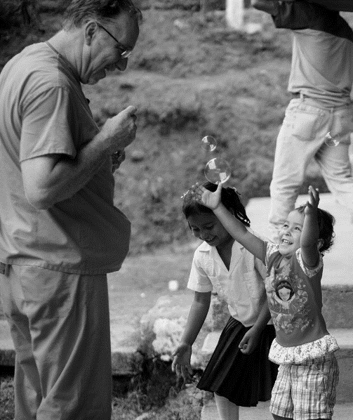
People of faith have a giving heart, especially those who serve on FOB mission teams. Often, we see needs that the staff have that we want to provide for separately from the work of the team, as a gift. So, what’s wrong with a gift to someone you’ve worked with all week by your side, who helped, sometimes heroically to make our mission successful? Why can’t we give them a gift of a few dollars or something that we brought (sometimes just for them, requested the last time we were there)? Or why can’t we respond to a need voiced in a private conversation with one of the local people that we could easily meet with little or no effect on ourselves?
The answer to these questions is the same…it’s wrong. Just because we can give a gift doesn’t mean we should. Every time a personal gift is given, or a gift is requested, the fabric of carefully nurtured mutuality and equality begins to unravel. The giver receives a sense of feel-good, a natural response, when giving. The receiver may be getting a gift, but he/she now knows that the giver and the receiver are no longer equals, creating an atmosphere of dependency, not one of mutuality and equality.
Here are some GUIDELINES to keep in mind when serving as a missioner on FOB mission teams:
- Gifts (money, computers, shoes, clothes, toys, or anything else) are not to be given or promised either during your time in Honduras or sent later.
- A request for favors from staff members (including translators) in private conversations is a serious breach of protocol and should be reported to the Team Leader and/or FOB Honduras Director.
- Promises of future gifts are inappropriate. This includes medical equipment, procedures, or medications that a patient may need.
- Asking staff members to tell you what they need is inappropriate.
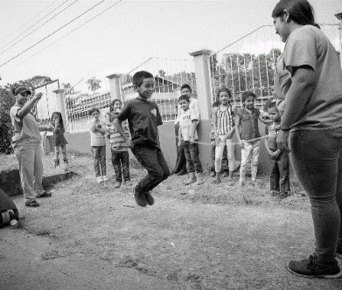
- Giving toys to children in the villages is inappropriate.
What is the best way to celebrate equality in a manner that encompasses the principles of generosity and compassion without creating bad feelings and partiality? Here are some SUGGESTIONS…
- Smiles, high fives, handshakes, hugs
- Play games, color with children
- Offer to listen, to sit, to pray; eat together, share food together
- Be inclusive; Hondurans traveling with the team are team members too; don’t leave them out of activities and devotions if they are present.
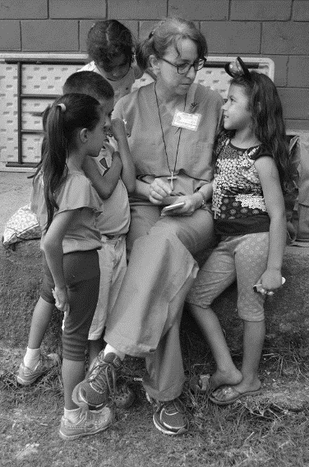
***FOB POLICY *** The only non-formulary items permitted to be distributed by FOB mission teams are as follows: (1) Flip flops, baby slings, and diapers will be utilized and disbursed from the medical stations as they are needed. (2) A soccer ball/frisbee will be used to bridge the gap between cultures, allowing team members and community members and children to play with one another. These will be given to the school teacher at the end of the day for future use.

What Is Required of Me?
Thank you for making the commitment to travel with FOB to serve the people of Honduras. After thoroughly reviewing the contents of this Handbook, please complete the following according to the deadlines provided by your Team Leader.

1 – Register with:
- US Embassy
2 – Complete:
- UMVIM Missioner Profile and Release of Claim Form WITHIN TWO DAYS OF RECEIPT OF EMAIL FROM UMVIM
3 – Provide Team Leader with:
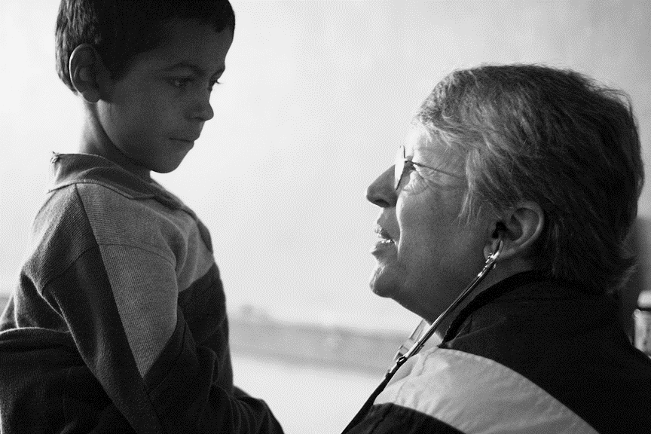
- Completed copy of Team Member Information Form
- Completed copy of Volunteer Agreement
- Completed copy of Medical Release Form
- Completed copy of Physician Release Form
- Passport Copy (color copies must be submitted by all medical professionals)
- Parental Consent Form, if team member is a minor (request form from your Team Leader)
4 – If you are a medical professional, please also submit:
- Copy of current medical license
- Curriculum Vitae (physicians only)
- Copy/Photograph of diplomas (physicians only)

Thank You!
Thank you for your service to Friends of Barnabas and to the people of Honduras. Thank you for being an integral part of FOB’s Community Health Development Program, providing services and preventative health education to 30 rural mountain communities in Honduras. Your support is invaluable!

Friends of Barnabas would also like to thank our current Community Partners. These families, churches, and civic organizations have made a significant commitment to promoting sustainable changes and improving the overall community health of our 30 communities.

- Barbara Reid and Family
- The Bruce Carter Family
- Farmville UMC
- Grace Lutheran Church
- Harmony UMC
- Howard Chapel UMC
- Reveille UMC
- South Richmond Rotary
- Trinity UMC
- Warwick UMC

To learn more about our Community Partnerships, please reach out to Ashleigh at ashleigh@fobf.org or 804-744-5624.

